**PROCEDURE OF MIGRATE TO AMAZON RDS**

1. 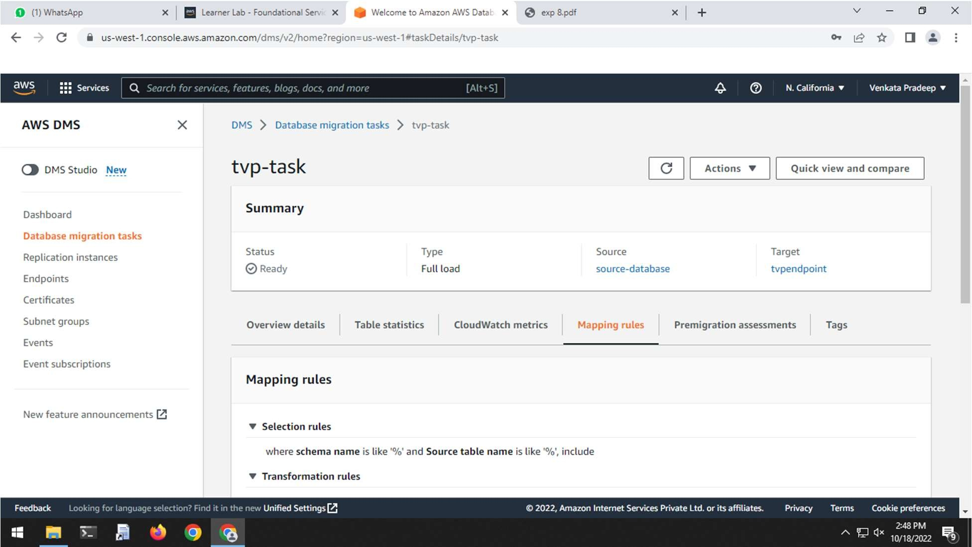Login to your AWS account
2. Search for DATABASE MANAGEMENT SERVICE

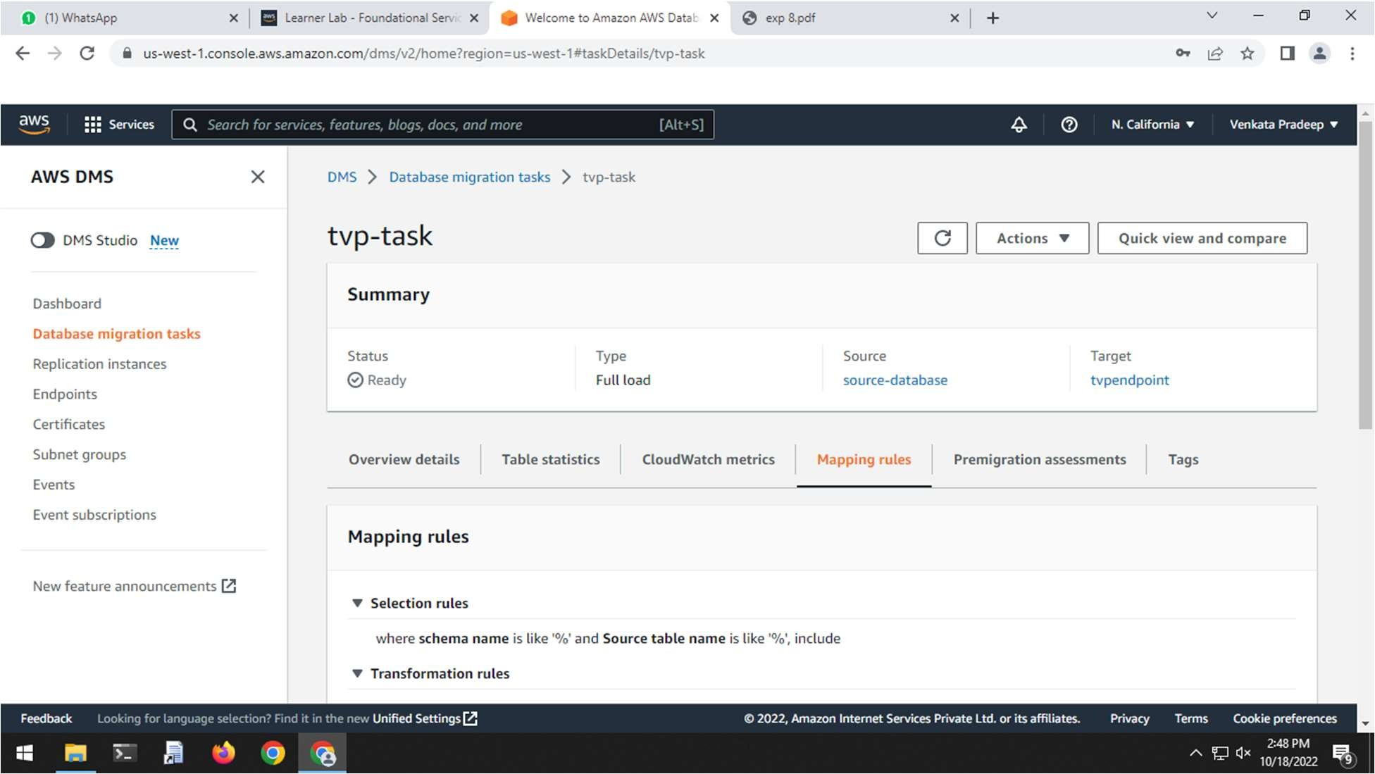

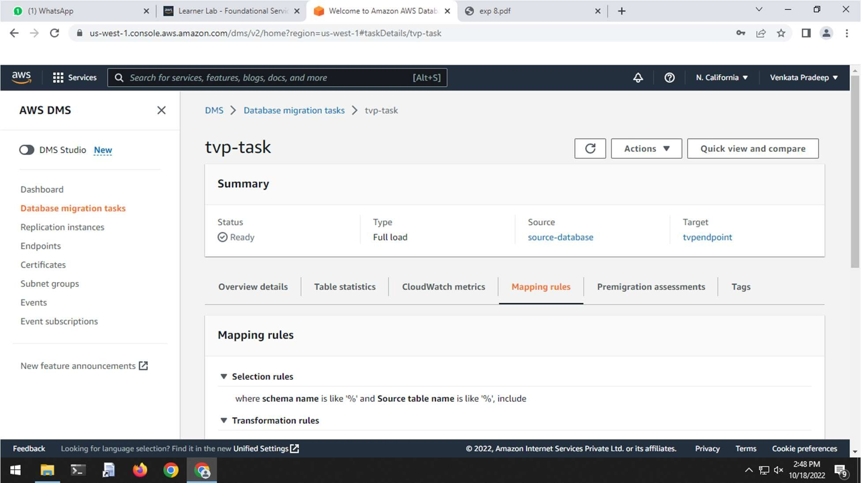

1. Open REPLICATION INSTANCES

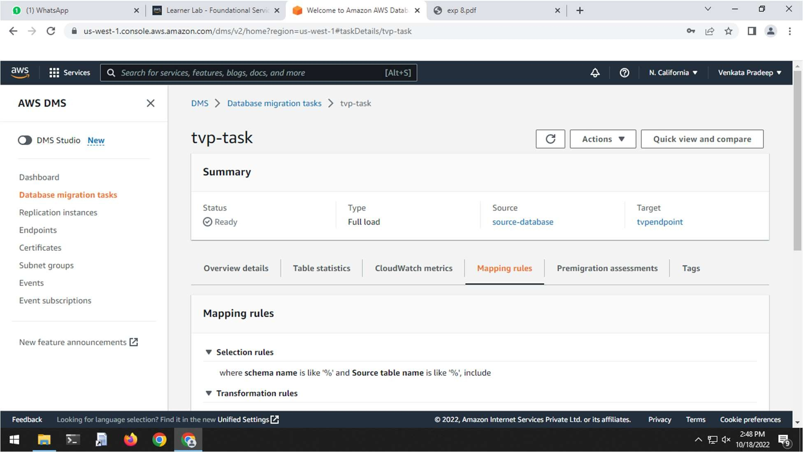

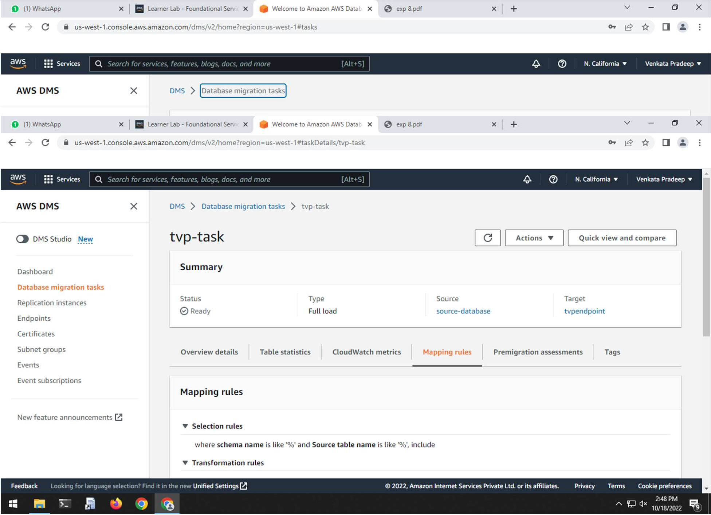

1. Click on CREATE REPLICATION INSTANCE
2. Enter your replication instance NAME, DESCRIPTION

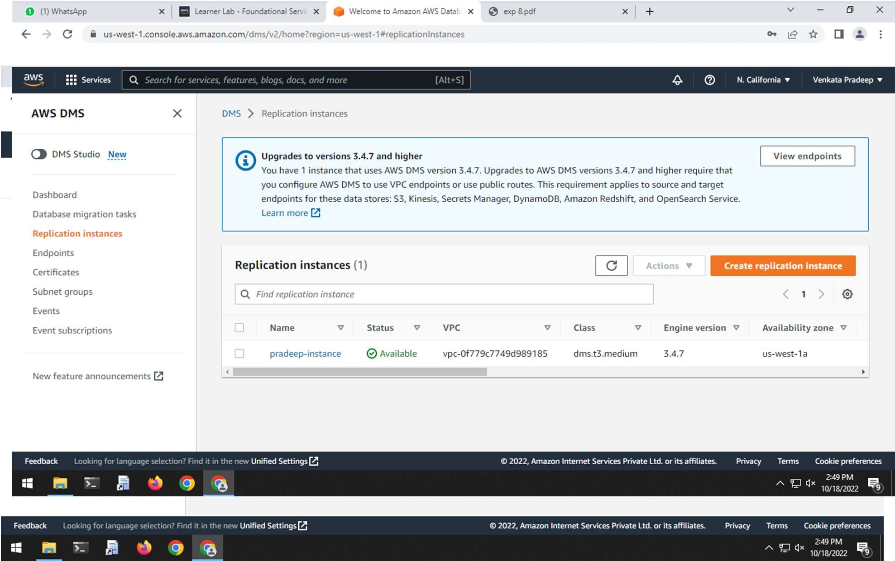

1. Give the required details and click CREATE

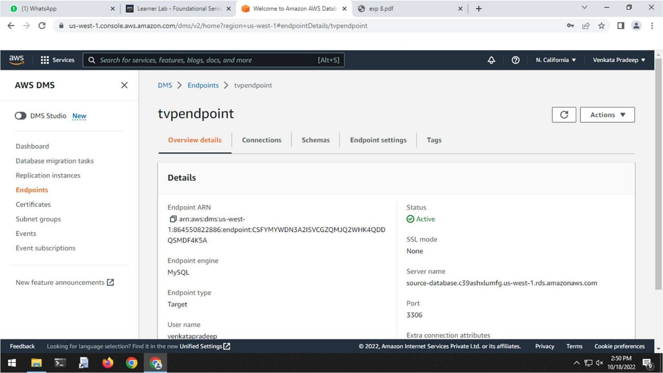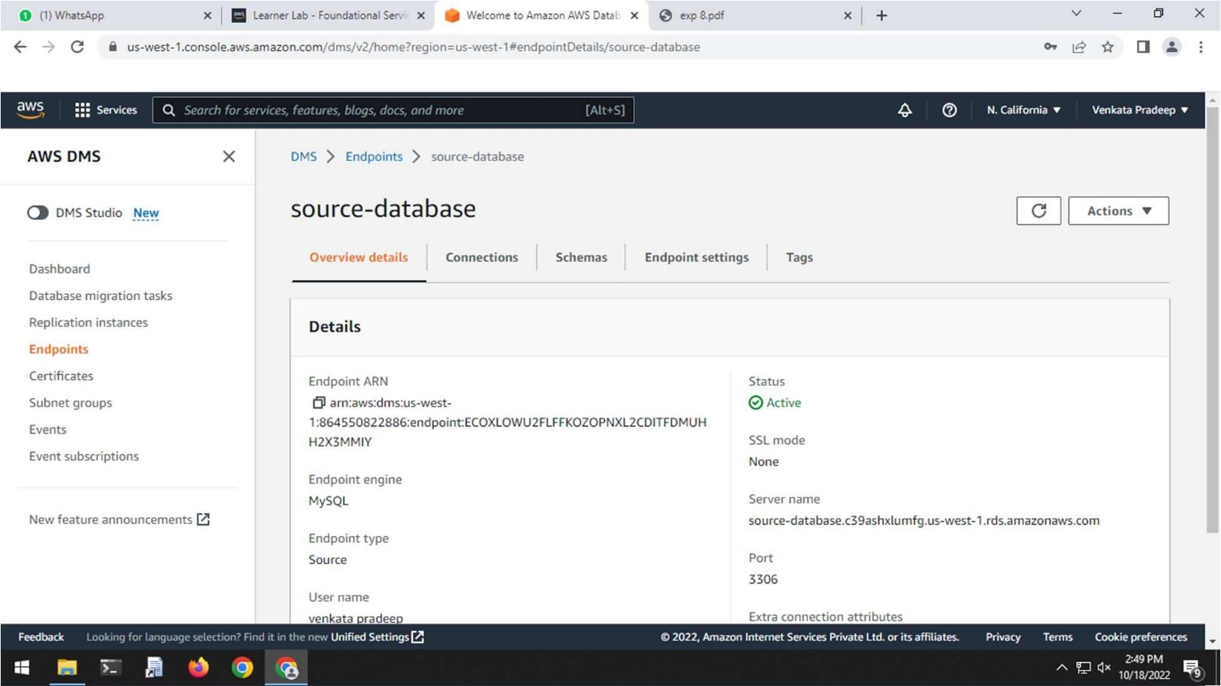

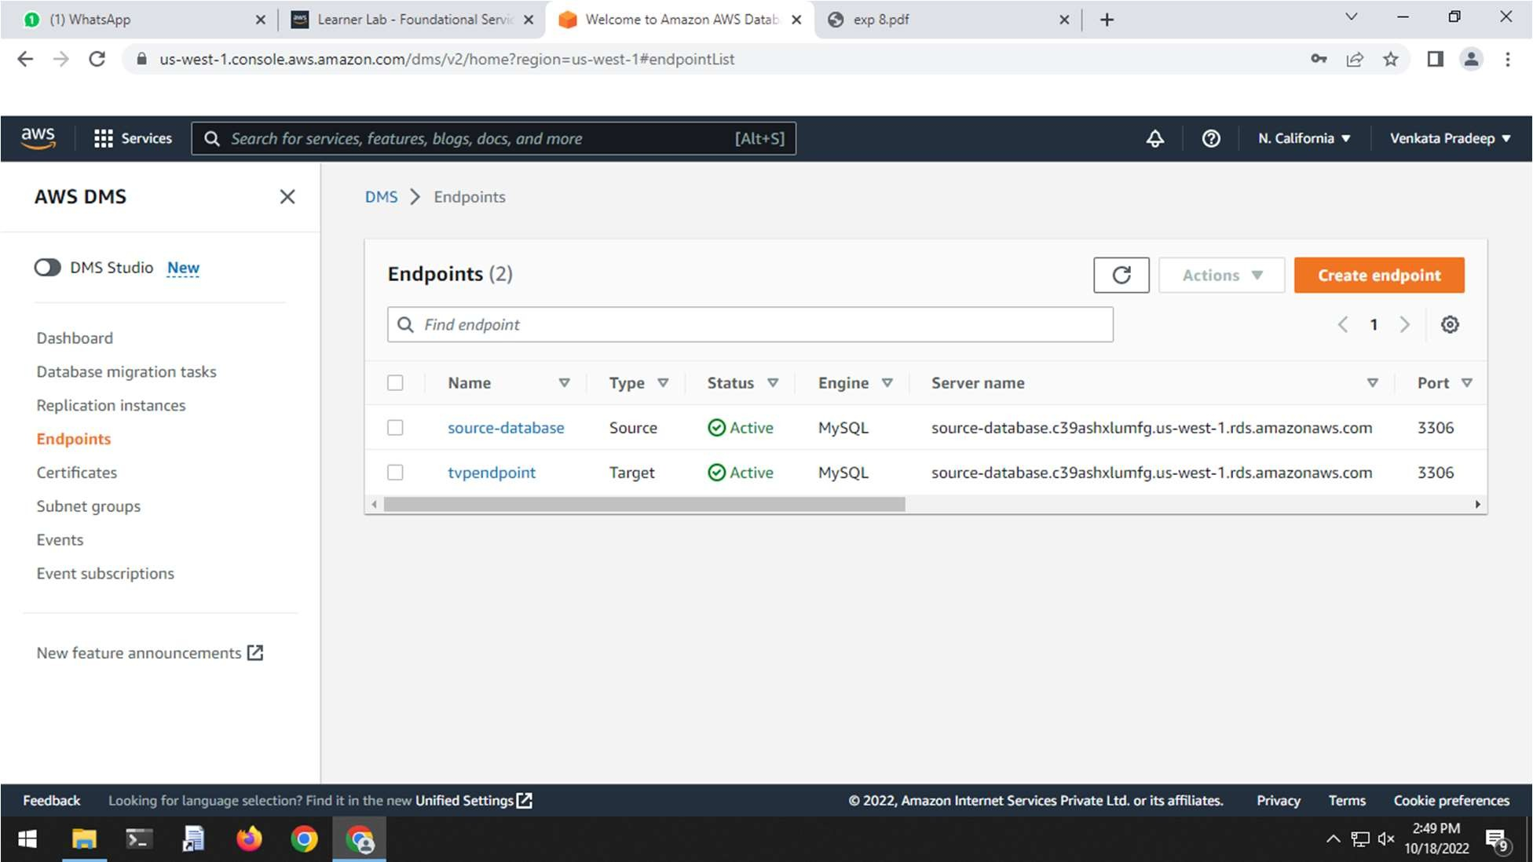

1. From the console choose ENDPOINTS and create endpoint

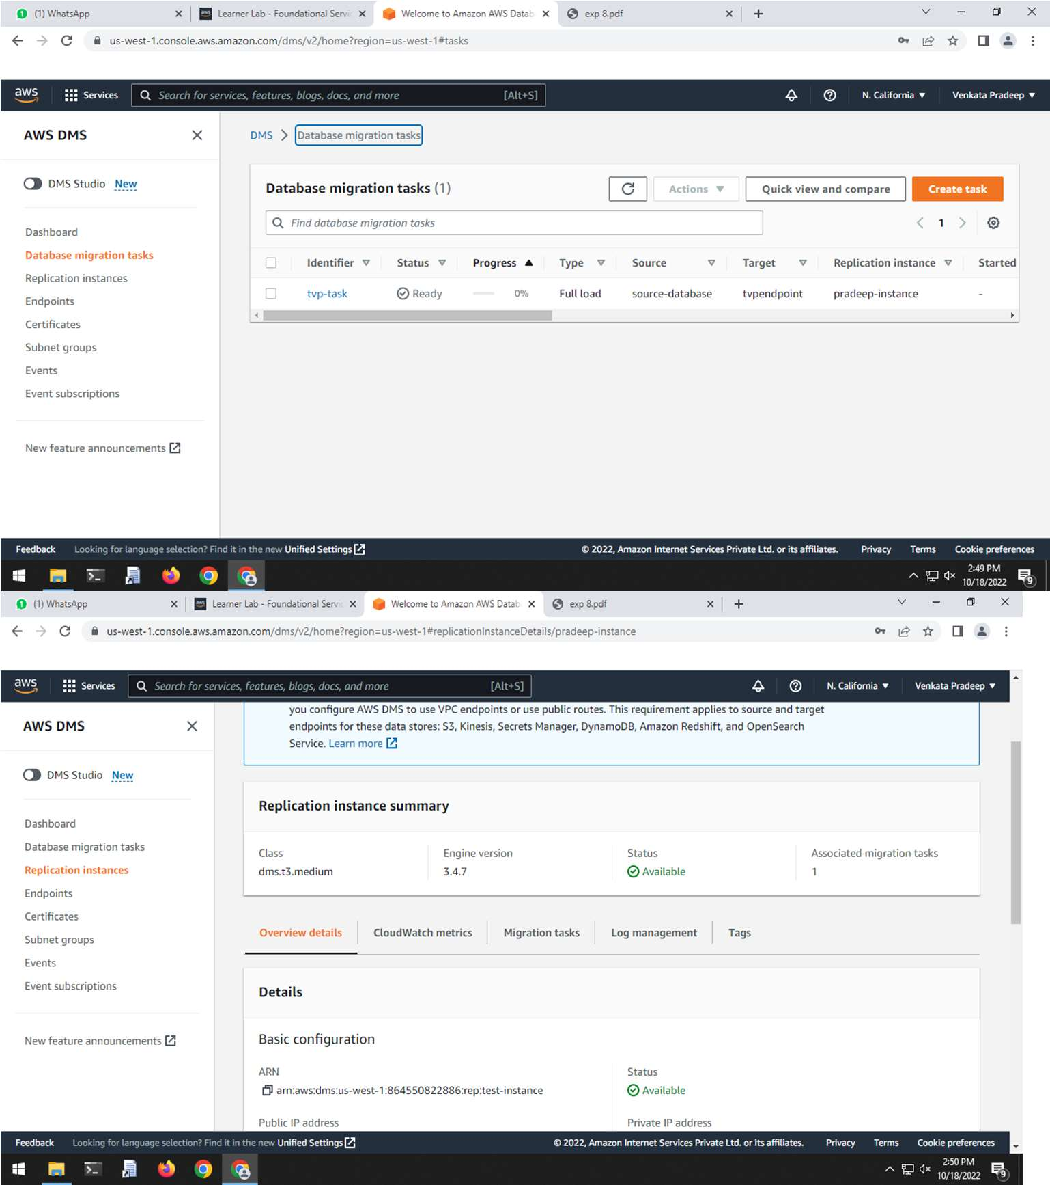

1. Select the ENDPOINT TYPE
2. Choose RUN TEST button and when the status is successful click on CREATE ENDPOINT
3. Repeat the above steps to create an instance but this ENDPOINT TYPE is Target endpoint
4. Choose the DATABASE MIGRATION TASKS on the console and choose CREATE TASK
5. Create the task by giving required details
6. Click on Migrate existing data for one time migration and in task setting update the fields as required.
7. After giving the required details choose create task.
8. Run the task.
9. Click on the task and click TABLE STATISTICS to view the successfully completed tasks.

RESULT:

Finally, we have done migration to Amazon RDS.